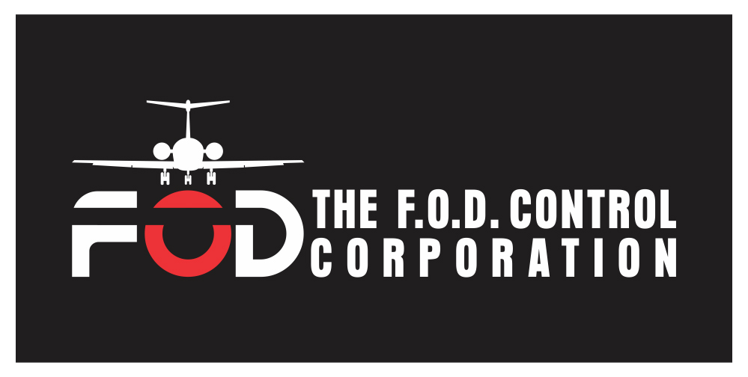
Flightline Grading Checklist
- Are the perimeter fences clean? _______
- Are outside trash cans covered and not overflowing? _______
- Are Construction zones clean or protected by fencing? _______
- Are baggage handlers eating and drinking on the parking ramp? ______
- Are baggage areas including tugs and trailers free of trash? ______
- Can you see luggage hardware or other debris on ramp surfaces? ______
- Are taxiway shoulders free of loose stones and grass cuttings? ______
- Are infields free of trash? ______
- Do vehicles entering the ramp stop and check their tires for FOD? ______
- If your facility has jets with low-slung engines, are there any objects that may be dangerously close? ______
- Do the maintenance personnel look sharp, neat and personally ‘FOD Free’ or are they bristling with items that could come loose and get to the ground? ______
- Are there bird attractants such as lakes nearby? Are any large birds such as gulls or geese visible from the airfield? ______
- Are there FOD containers conveniently accessible to work areas? ______

NOTES
____________________________________________________________________________________________________________________________________________________________________________________________________________________________________________________________________________________________________________________________________________________________________________________________________________________________________________________________________________________________________________________________________________________________________________________________________________________________________________________________________________________________________________________________________________________________________________________________________________

